St. Paul’s Lutheran Church
Quarterly Report to the Voters Assembly
October 25, 2020
12:30pm in the ARC and by ZOOM; virtual voting until November 8

Enclosed is the information presented by print, mail, and email to the October Voters Assembly including a copy of the Voters Meeting Agenda, the Minutes from the previous Voters Meeting in July, Pastor's Report and Official Acts, and Financial and Team Reports, along with Felicia Salgado’s request for a peaceful release, and the proposed 2021 Financial Plan needing approvals by vote. The Nominations Team Report for Election of 2021 Officers and Teams will be sent under separate communication as it is still under construction. Any comments or amendments by non-attendees must be submitted by Friday, October 23rd.
Once the live portion of the meeting has concluded, ballots will be made available by mail and email.
All confirmed members are invited to participate in our Virtual and Live Voters Assembly by reading these reports and submitting any questions by email (or calling the Church Office if you do not have email), or by attending the meeting in-person on October 25th at 12:30pm. Members who are twenty-one years of age or older are invited and encouraged to become part of the Voters Assembly; you may become a voting member by responding to the vote on the items presented by November 8. This is an excellent time to become part of the Voters Assembly and take part in the business of St. Paul’s Lutheran Church in proclaiming the gospel of Jesus Christ.
The October Voters Meeting will be conducted on Sunday, October 25 at 12:30 in-person in the ARC at St. Paul’s and by Zoom (the link will be emailed prior to the meeting) with voting to take place during the next 2 weeks, concluding by Sunday, November 8. If you have not been receiving weekly emails from St. Paul’s, then the Church Office does not have your current email address; please email ChurchOffice@StPaulsDec.com and request that your email address be added to our database. A paper ballot will be mailed to those members who do not have access to email.
These are unprecedented times, and the St. Paul’s Vestry has decided that since not everyone is comfortable meeting in-person during this pandemic, allowances have been made for participation virtually.

AGENDA

LIVE and VIRTUAL VOTERS ASSEMBLY MEETING
October 25 - November 8, 2020

CALL TO ORDER – Michael McRae
OPENING PRAYER – Pastor Kretzschmar
REVIEW OF CURRENT & ADMISSION OF NEW VOTERS –
By responding to the vote on the business items below, any member of St. Paul’s Lutheran Church that is 21 years or older will constitute the request to become a voting member and will suffice as a “present and voting” status for the Voters Assembly.
REVIEW OF JULY MEETING MINUTES – Pam Meadows
PASTOR'S REPORT – Pastor Kretzschmar
DCE REPORT and PRESENTATION OF PEACEFUL RELEASE REQUEST - Felicia Salgado
ELDER TEAM REPORT – David Burrell

EDUCATION TEAM REPORT – Maribeth Morgan

OUTREACH TEAM REPORT – Pedro Santaliz
TRUSTEE TEAM REPORT – Rich Maschke
FINANCIAL REPORTS – Alison Gilchrist
OLD BUSINESS
NEW BUSINESS.
- Nominations Team Report and Elections
- Proposed 2021 Financial Plan – Team Leader
- Other – please submit items by email (or calling the Church Office if you do not have email).

ANNOUNCEMENTS – Please continue to the refer to the website at www.StPaulsDec.com, weekly emails, phone calls, and texts for news and announcements; record your worship attendance on the homepage link; and continue to support the work of the Lord through this place with your tithes and offerings. Great ministry is happening and needs the continued support and prayers of every member!
ADJOURNMENT – The Lord’s Prayer
St. Paul’s Lutheran Church
Virtual Voters Assembly Meeting Minutes
July 26-Aug 2, 2020

Due to complications by the pandemic of meeting in-person for the July 26 Voters Assembly, the St. Paul’s Vestry deemed it appropriate to conduct the meeting by mail and email. In addition to communication concerning the mission and ministries of the congregation during the quarter (please see the Voters Packet), there were two resolutions introduced to the Vestry for consideration.
- Resolution #1 to the Voters Assembly for Adoption of KTT as a Ministry of St. Paul's Lutheran Church.
- Resolution #2 to the Voters Assembly to Share the Cost ($3,000) of the West Lot Fence with KTT.
The Vestry was unanimously in favor of both resolutions and wanted input and approval by the Voters Assembly. The Virtual Voters Meeting was announced at Worship services on July 19, July 26, and August 2, and the Voters Packet for the July Voters Assembly (see attached) was home-mailed to those who do not have an email address in our email database on Thursday, July 23 and emailed to all members in our email database on Saturday, July 25 and Wednesday, July 29. Phone call and text reminders to all members in our OneCallNow database were completed by Monday, July 27. The Voters Packet may also be found on the Links tab of the church website, www.StPaulsDec.com. The balloting for the two resolutions were to be completed by either returning the ballots by mail, bringing them to the Church Office, or responding to the Online Survey provided in the communications, and any questions concerning the resolutions were to be asked by email or by calling the Church Office; there were 3 inquiries.
The balloting results are as follows:
5 votes were returned to the Church Office:
5 votes were in favor of Resolution #1
5 votes were in favor of Resolution #2
52 votes were cast by online survey:
50 votes were in favor of Resolution #1; 2 votes were opposed to Resolution #1
47 votes were in favor of Resolution #2; 5 notes were opposed to Resolution #2
57 total votes were cast
55 votes were in favor of Resolution #1; 2 votes were opposed to Resolution #1
52 votes were in favor of Resolution #2; 5 notes were opposed to Resolution #2

Thank you to the following participants whose names are added to the Voters List going forward:
Carol Morgan, Michael Salgado, Don Olson, James Forthman, Maribeth Morgan, Ron Seibert, Bobbie Seibert, Helga Daniel, Paula Brown, Bonnie Mann, Ronnie Atkins, Ricky Daniel, Helga Daniel, Robert Sullivant, Susan Sullivant, Rhonda Reece, John Nelson, Meghan Carroll, Ron Neuendorf, Bo Paradise, Melinda Carlson, Sue Bosco, Mike Bosco, Joy McMinn, Mark McMinn, Ron Fritze, Jennifer Kimmett, Steve Kurtz, John Mann, Jimmy Mueller, Carol Mueller, Celia Faller, Christi Kurtz, Nancy Neuendorf, Carol Mueller, David Burrell, Jane Burrell, Rusty Nicholson, Jeff Morgan, Jackie Joiner, Kathleen Obrien, Tommy Livingston, Dee Livingston, Beth Hornish, Alison Gilchrist, James Gilchrist, Cyndi Todd, Craig Faller, Michael Ater, Shari Jones, Dan Jones, Michael McRae, Joan McRae.

The next Voters Assembly meeting is scheduled for October 25; the Vestry will determine if it will be conducted in-person or virtually by mail/email.

Respectfully submitted,

Carol Morgan

St. Paul’s Voters Meeting – October 25, 2020
Rev. Dr. Aaron C. Kretzschmar

“First of all, then, I urge that supplications, prayers, intercessions, and thanksgivings be made for all people, for kings and all who are in high positions, that we may lead a peaceful and quiet life, godly and dignified in every way. This is good, and it is pleasing in the sight of God our Savior, who desires
all people to be saved and to come to the knowledge of the truth.”
(1 Timothy 2:1-4)

Pray for the United States of America
October newsletter emphasis—1 Timothy 2:1-4
Please encourage our fellow members to pray fervently during these days
In general, we see competing worldviews (secular and Biblical) in these times

Thank you for your contacts with and encouragement of fellow St. Paul’s church family members

Current Sunday Worship Opportunities
Drive-In Worship Service at 8:00 AM
Sanctuary Worship Service at 9:30 AM (with Facebook Live simultaneously)
Radio Worship Service at 11:00 AM (Live on 98.5 FM)

Cool Weather Sunday Worship Schedule starting November 1st
Sanctuary Worship Service at 8:15 AM (with Facebook Live simultaneously)
Radio Worship Service at 9:30 AM (Live on 98.5 FM)
Drive-In Worship Service at 11:00 AM

Sermon Transcripts are being mailed to members that cannot connect by other means

Upcoming Midweek Worship Services
Noon on Thanksgiving Eve (with Facebook Live simultaneously)
Noon on Wednesdays for Midweek Advent (with Facebook Live simultaneously)
Radio Service time to be determined

Midweek Advent Sermon Series: Stories of Advent
Advent Silence: Zechariah’s Story (Luke 1:5–24a, 57–64)—December 2nd
Advent Faith: Mary’s Story (Luke 1:26–38) —December 9th
Advent Action: Joseph’s Story (Matthew 1:18–25) —December 16th

Catechesis
Currently by Zoom for Youth Confirmation Class on Wednesdays at 6:00 PM
Youth Confirmation Class will begin meeting in-person on Wednesday, November 4th at 6:00 PM
Adult Confirmation Class to continue by Zoom on Wednesdays at 8:00 PM

Drive-In Praise Team Practice – Wednesdays at 7:00 PM

Chapel for Children and Youth
Preschool Chapel—I lead the devotion every other Thursday at 10:00 AM
KTT “God’s Place” Chapel Time—I lead service every other Wednesday at 4:00 PM

Visits with Homebound Members – continue by phone, and in-person for some

Counseling of St. Paul’s members and people from the community continues with social distancing

Trek or Treat (a drive-thru Trunk or Treat)
Wednesday, October 28th from 5:30 to 7:00 PM
More trunks are needed for this event
Please consider volunteering to host a trunk (contact the Church Office if interested)
Bible Study Opportunities
Adult Bible Studies
Sundays at 11:30 AM—A study on Galatians led by Michael McRae through Zoom
Wednesdays at 6:00 PM—A Romans study led in-person by Mike Widmar
Director of Family Ministries (Felicia Salgado) Led/Directed Studies and Efforts
Women’s Bible Study (Wednesdays at 10:00 AM by Zoom) Altogether Beautiful
Virtual Sunday School—Children’s Bible Time posted on Facebook on Sundays at 9:00 AM
Middle School Youth Zoom—Sundays at 6:00 PM
Monthly High School Fellowship Activities

Prayer Shawl Ministry – Thursdays at 11:00 AM

Please continue to pray for St. Paul’s members, and pray about the upcoming election.

Membership Gains and Losses, July 1 – September 30, 2020

3rd Quarter

Baptized Membership, 7/1/2020 551  Removed by Transfer of Parents or  Moving without Transfer (never confirmed) 29  Removed below (confirmed) 78  Total Baptized Membership, 9/30/2020 443 | 564 at end of 2019
Confirmed Membership, 7/1/2020 465  Gains  Juniors Confirmed 3  Losses 4  Removed by Transfer to other LCMS 2  Removed by Moving without Transfer 76  (Elders contacted those who had not worshipped here in over 5 years to confirm desire to be removed)  Total Confirmed Membership, 9/30/2020 386 | 472 at end of 2019  Jack Blaske 07/26/2020  Celia Gilchrist 07/26/2020  Maggie Nicholson 07/26/2020  Tom Pittman 08/22/2020  Ann Peck 09/18/2020  Don Havercroft 09/23/2020  Bette Thomas 09/24/2020  Ian Thies 07/19/2020  Quintin Thies 07/19/2020

RELEASE LETTER FROM FELICIA SALGADO
October 25, 2020
Dear Members of St. Paul’s Lutheran Church:
I am writing to request a peaceful release from my call as DCE, effective December 31st to take care of some health issues apart from my day-to-day duties as a full-time minister.
Thank you for your patience over these two years as I have grown as a DCE serving in many areas of ministry for the first time.
Thank you for entrusting your children and teens to me -- they have been such a blessing to me during these past two years, and I pray that I’ve blessed them in some way as well.
Thank you for every way you all so willingly served alongside me in ministry. If you believe I served well, it was only by God’s grace and your helping hearts and hands.
Lastly, thank you for welcoming my family so lovingly. We came to St. Paul’s as strangers, and now we are part of this family.
Friends, I appreciate your prayers during this transitional time. My family and I are so grateful for you and love you all.
With love,
Felicia Salgado

Elder Report to Voters
10/25/2020
Worship Schedule
Sunday morning changes: A decision was made on the schedule for worship services anticipating colder weather and its impact on the Drive-In service. Also, the Sanctuary worship service schedule will be changed as we begin the process of returning to “normal.”
Starting November 1, the schedule will be:
Sanctuary In-person Worship Service @ 8:15 AM with Facebook livestreaming
Radio Worship Service @ 9:30 AM
Drive-In Worship Service @ 11:00 AM
Communion Set Distribution will continue for those worshiping by Facebook Live and by Radio broadcast with sets being distributed on Tuesday and Thursday (Oct 27th & 29th @ noon & 5pm); sets are available at the In-Church and Drive-In services.
Special Worship schedules:
noon services in-person with the services live-streamed on Facebook and available for viewing anytime following.
Thanksgiving Eve (Nov 25)
Advent (Dec 2, 9, & 14)
Pastor will begin conducting youth confirmation class in-person on Wednesday, November 4th in the ARC.
Fellowship Picnics on the Lawn this fall have been very successful in providing fellowship time while respecting distancing practices.
Five Elder positions will need to be filled at the next Voters when the terms of Mark Blaske, Jimmy Mueller, Rick Daniel, John Mann, and Dave Burrell complete at the end of the year.
Respectfully submitted,
Dave Burrell
Education Team Report
October 2020

Preschool
- DHR exemption paperwork complete and in the mail, approval should be complete in November.
- ENROLLMENT UP to 53 Children currently enrolled; 13 are only preschool hours.
Dates
    - October 20th (rain date Oct. 21st) St. Paul’s Pumpkin Patch
Since we are unable to take a field trip, we will have a pumpkin patch and activities at school
- October 29th at 12:00: Costume parade
- November 8th: Virtual Preschool Sunday during Sanctuary Service - The children will sing for our congregation as a way to thank them for their continuing support of our ministry.
- Please see Nancy’s complete report below

Elementary
- NEED: a new Sunday School Superintendent
- Currently holding weekly bible stories via Facebook group
- Planning for a virtual Christmas video of some kind
- Advent boxes to go along with Christmas planning.

Middle School
- Confirmation returning to in-person Nov 4th With Zoom available.
- Middle School zoom meetings on Sunday evenings at 6 pm. Looking at the future to move to 7 pm and transferring to bi-weekly and adding in person events.

High School
- NEED: High School Youth Leader
- Having monthly events in person. November’s theme is a Bob Ross Painting event.

Young Adults
Still having individual check-ins with young adults.

Adult Ministry
- MOPS still meeting working through schedule
- Mike McRae still hosting online bible study through zoom
- Mrs. Felicia is leading a women’s bible study at 10 am and recording for re-watch
- Mike Widmar hosting in-person bible study Wednesday at 6 pm
- Adult confirmation class began Wednesday August 26th at 7:30 pm

Additional Ideas/Concerns:
- Mrs. Felicia stepping down at the end of the year. Working on a Job description for an intern in the coming year. Please submit any input for this position by December 31st.

Maribeth Morgan
Education Team Chairman

Preschool Report to Congregation
October 25, 2020

DHR Exemption
- Fire inspection completed
- All new staff have completed DHR mandated fingerprinting and background checks.
- Parents have signed and notarized forms on file indicating their knowledge that we are a DHR-exempt program
- Our exemption should be approved in November
Enrollment
- 53 children currently enrolled
- 13 are ONLY Preschool hours
- We currently have 7 teachers/ 3 morning workers/afternoon office assistant/ 1 classroom aide position/ and 4-5 afternoon workers
- We will need to add a classroom aide on Wed. and possible Thursday as well as another afternoon worker on Monday and Wednesday. Teachers will be offered the positions first, followed by staff currently working. If necessary, we will advertise on Facebook, etc…
Dates
- October 20th (rain date Oct. 21st): St. Paul’s Pumpkin Patch - Since we are unable to take a field trip, we
will have a pumpkin patch and activities at school
- October 29th at 12:00: Costume parade
- November 8th: Virtual Preschool Sunday during Sanctuary Service
The children will sing for our congregation as a way to thank them for their continuing support of our ministry.

2021 Proposed Budget Plan
Under Utilities/Janitorial Supply copayments, $29,586 is a reapportionment which more accurately enumerates congregational support of the Preschool Ministry. During our latest NLSA accreditation it was recommended that St. Paul’s Lutheran Church provide greater financial support to the program. We feel that this is a more accurate depiction of the support that is in place. This represents 9% of our total budget.

Prayerfully submitted,
Nancy Neuendorf
Director, St. Paul’s Lutheran Preschool with Extended Care
“Early Childhood Education with Jesus at the Center of Every Activity”

Parish Outreach
KTT Inc Afterschool Program
Report to Congregation
October 25, 2020

KTT Inc resumed our services August 17 as a non-profit afterschool program with fourteen children attending. Because the parents were given a choice for their students to be virtual or traditional at school, many chose virtual learning. and our numbers were drastically affected. To date, we are serving twenty-five children. As of Monday, October 19, we will have two additional children returning.
We have several new enrichment programs that have been added to enhance our afterschool program that we're super excited about. They are tennis, coding for grades 3rd-8th grade, and the Princesses of Grace Tweenz middle school group.
God has truly blessed this ministry as we work through the Covid-19 environment. We solicit your continued prayers, donations, and volunteers to tutor / mentor the children.
Respectfully submitted,

Charlotte Bradley, Director
KTT Inc
Parish Outreach
Report to Voters on Livestream Upgrade Project

Don Olson and Rich Maschke mentioned that Central Park Baptist was willing to sell their multi-camera SlingStudio platform due to their plan to upgrade their system. A price has not been yet determined.
The following is a list of prices for each system component.

 | Option 1 |  |  | Option 2
 | Item |  | Amount | Item |  | Amount
Hardware | VCD* |  | $0
 | Camera |  | $399.99
 |  |  |  | PTZ |  | $1,599.99
 | Computer |  | $820.26 | Computer |  | $820.26
 | Audio Interface |  | $159.99 | Audio Interface |  | $159.99
 | Total |  | $1,680.24 | Total |  | $2,580.24
Software | ProPresenter |  | $400.00 | ProPresenter |  | $400.00
 | Easy Worship |  | $18.00 | Easy Worship |  | $18.00
 | restream |  | $20.00 | restream |  | $20.00

Note: ProPresenter has a free version or can be purchased for $400.00. Easy Worship is a similar application that is a monthly subscription, as is restream.
*A Video Capture Device (VCD) was donated to the church, identity unknown – thank you!
Computer: Dell Inspiron 5000 series 15.6" Customized Laptop Intel Quad-Core i5-8265U Processor 24GB RAM 128GB SSD.
Camera: Mevo Plus
PTZ: PTZOptics 12x SDI Gen2 camera
Audio Interface: Focusrite Scarlett 2i2 3rd Gen
Pedro Santaliz

Trustee Team Report to Voters
October 25, 2020
>completed Preschool storage unit
>working on exit sign testing and repairs
>toilet repairs
>outside lighting relamping

open items:
-2 pole lights outside near electronic sign are out and need replacement. will need to rent a lift but holding off until lift is needed for inside lights as well.
-electronic sign replacement or repairs
-live video setup of services. still trying to decide on a setup. cost of around $3000 can be covered under existing dedicated funds.
-discovered old squirrel hole damage to siding. Have verified the hole is not being used now but still needs to be permanently closed.

Rich Maschke
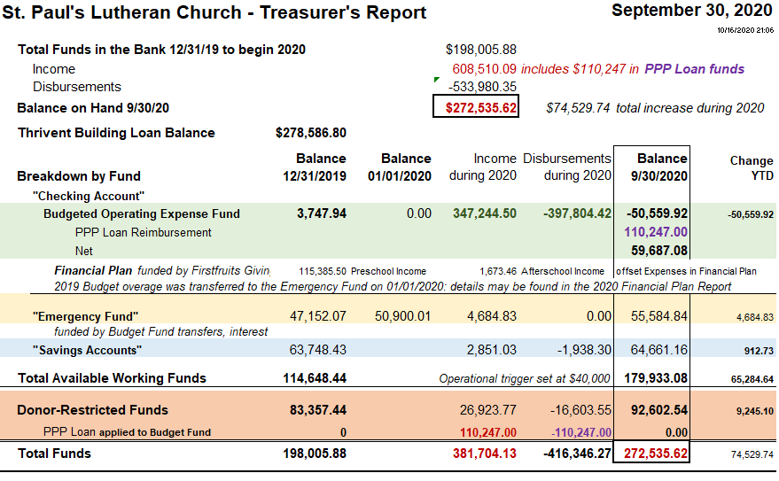

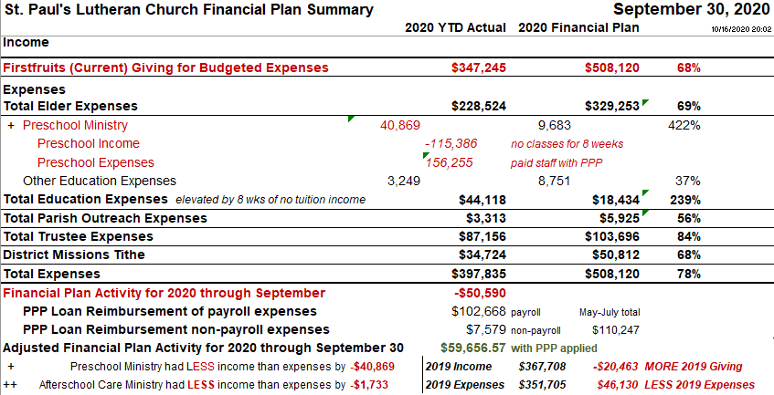

2021 Proposed Financial Plan

2021 Proposed |  | prev 12 mos |  |  | Proposed
Financial Plan | 2019 | Sept19-Aug20 | 2020 |  | 2021 | Percent | Notes
 | Actual | Actual | Plan |  | Plan | Change
Current Income | 488,671 | 470,675 | 508,120 |  | 496,781 | -2%
Elder Expenses | 314,631 | 313,368 | 329,253 |  | 299,156 | -9% | reflects 2% COLA for full-time staff, change in DCE position to intern
Education Expenses | 5,853 | 45,091 | 18,434 |  | 39,260 | 113% | reflects Preschool 3% staff wage increase, updated increased shared cost for janitorial, utilities copays of $29,596 - offset in Trustees below
Outreach Expenses | 5,551 | 2,944 | 5,925 |  | 9,790 | 65% | reflects KTT updated increased by shared cost for janitorial, utilities copays of $13,005 - offset in Trustees below
Trustee Expenses | 110,030 | 109,775 | 103,696 |  | 98,897 | -5% | reflects 2% for COLA janitors, budget for 1 HVAC unit, offset by higher Preschool, KTT copays
Mission Payments | 48,857 | 47,083 | 50,812 |  | 49,678 | -2% | 10% of Firstfruits Giving
Total Expenses | 484,922 | 518,260 | 508,120 |  | 496,781 | -2%
Net Income | 3,749 | -47,585 | 0 |  | 0

VOTING INSTRUCTIONS
EVERYONE is welcomed and encouraged to respond by email or by calling the Church Office at (256) 353-8759 with questions or comments.
ANY amendments to these motions may be made by email or phone call by Friday, October 23rd to be considered by the meeting attendees for modifying the motions below.
Once the Live meeting has concluded on October 25, ballots and instructions for the following anticipated items of business will be emailed and mailed to those without email. All members of St. Paul’s 21 or older may participate in the voting process which is open until Sunday, November 8.
- Motion to accept the peaceful release of Felicia Salgado from her call to St. Paul’s as DCE and to continue to pray for God’s blessings in her life, health, and ministry to the Lord. Details on page 5.
- Motion to accept the 2021 Slate of Officers and Team Members as proposed in the 2021 Nominating Committee Report. Details on page 11.
- Motion to accept the proposed 2021 Financial Plan. Details on page 10.
2021 Nominating Committee Report
October 2020
Officers:  Chairman –  Secretary –  Fin Sec –  Treasurer – | 2021 Nominated  Melinda Carlson  Sue Bosco  Don Olson | 2020/2021 Returning  Michael McRae | 2019/20 Retiring  Pam Meadows  Alison Gilchrist  Susan Staudt

Teams/Boards:  Education Chairman –  Outreach Chairman – | 2021/2022 Nominated  Pedro Santaliz | 2020/2021 Returning  Maribeth Morgan | 2019/20 Retiring  Pedro Santaliz

Elders | 1 John Mann  2 Mike Widmar  3 Bob Sullivant  4 Dave Burrell  5 Mike Ater | Craig Baker  Phillip Corlew  Mike Ringers  Ronnie Atkins  James Gilchrist | Mark Blaske  Rick Daniel  Dave Burrell, Chairman  John Mann  Jimmy Mueller

Trustees | 1 Rich Maschke  2 Connor Baker  3 Rusty Nicholson  4 Mike Bosco  5 Sue Bosco | Steve Kurtz  Don Olson  Sal Salgado  Roy Weiland  Mickey Whiteside | Mike Bosco  Sue Bosco  Rich Maschke, Chairman  Rusty Nicholson  Connor Baker
Respectfully Submitted,
St. Paul’s Vestry

